HOOKE’S LAW EXPERIMENT

Student’s Name:

Date of submission:

Institution Affiliation:

ABSTRACT
Robert Hook discovered a law which states that when an elastic spring is loaded, the force applied is directly proportional to extension produced. In this evaluation, we plan to contemplate the flexible characteristics of the spring and the fprce consistent of the spring. We plan to reflect on consideration on the relationship among the twisting strength and sum the spring extends.

INTRODUCTION

Flexibility is the property of a piece of writing or fabric which makes it's reestablished to its particular form after mutilation. It's far stated to be progressively flexible on the off chance that it reestablishes itself all the greater correctly to its specific layout. An elastic band can be stretched and snaps again to close to its unique period while discharged, yet it isn't always as flexible as a piece of piano twine. The piano wire is greater diligently to increase, however could be stated to be extra flexible than the elastic band resulting from the exactness of its arrival to its specific length.

Hooke's law is a regulation of versatility determined through the English researcher Robert Hooke in 1660, which expresses that, for commonly little disfigurements of an object, the uprooting or length of the misshaping is straightforwardly corresponding to the distorting strength or burden. Underneath these situations, the article comes back to its specific form and endless supply of burden. The misshaping power is probably connected to a sturdy via extending, compacting, or curving. Alongside these strains, a metallic twine indicates flexible conduct as indicated by using Hooke's regulation in mild of the truth that the little increment in its length while prolonged by a linked power pairs each time the electricity is extended.
Numerically, Hooke's regulation expresses that the linked strength F rises to a regular k instances the relocation or alternate long x, or F=kx. The estimation of ok relies upon not just at the form of bendy cloth under thought yet in addition on its measurements and form.

Hooke's law is probably likewise communicated regarding anxiety. Strain is the energy on unit zones inside a material that creates due to the remotely connectedforce. Stress is the relative misshaping created by strain.

- MATERIALS AND METHODS

The materials required for this research are 1 set of Hooke's regulation apparatus, 1 piece 4N/m spring, 1 piece 8N/m spring, 1 piece mass holder and 1 set of mass. Fig (1) demonstrates an photograph of the materials.
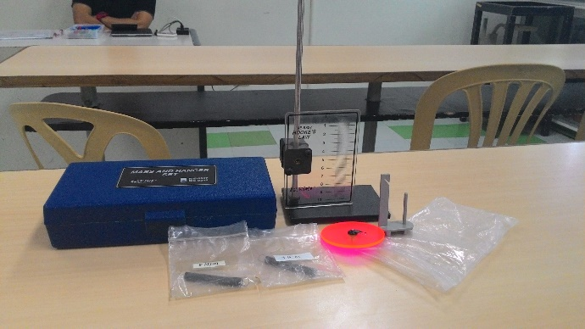
Fig 1 shows materials used in this experiment
Previous to continuing with the research, there are a few updates toward hardware care. By no means enlarge the spring extra than twice its resting duration, it may forever damage the spring.

Initial segment of the check is setting up the mechanical meeting. The spring was swung from the notch at the assist arm. The stretch marker was associated with the bottom of the spring. The clip at the assist bar turned into balanced till the pointer perusing is adjusted at precisely zero, at that point the mass holder become associated on the bottom of the stretch marker. Determine (2) and (three) demonstrates the set-up of the mechanical meeting.
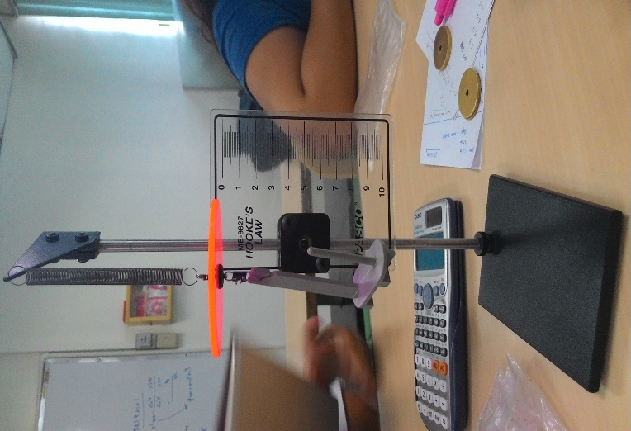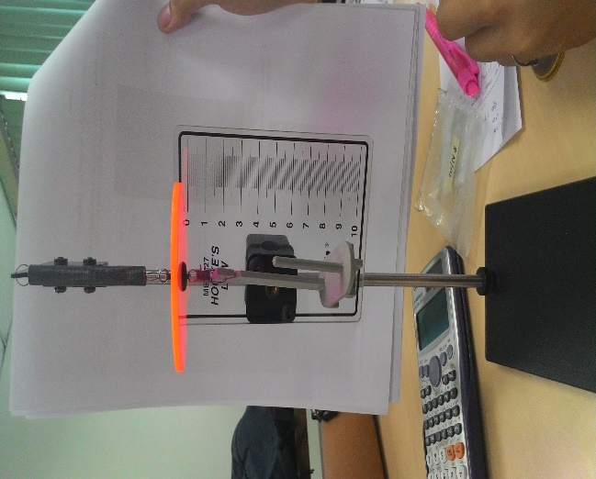
Fig2 shows a spring of 4N/m
Fig 3 shows a spring of 8N/m
Second part of the experiment is determining the force constant of the spring. To start, a mass of 10 grams was placed on the mass hanger as shown in Figure (4), then the change in displacement of the spring and the weight of the hanging mass was recorded. Spring was computed using the formula;
(1)
F = k*x
Where
F =force (N)
x = displacement (m; cm)
k = force constant (N/m; dynes/cm)

Equal strategies was made to the subsequent 3 preliminaries and in line with preliminary, a 10 gram mass is being included. The normal estimation of the strength steady became resolved at that factor plot a power as opposed to dislodging chart. The fee comparison of the everyday estimation of the energy consistent and incline of the road become decided. The strategies become rehashed, but this time some other spring become applied seemed in figure (five).
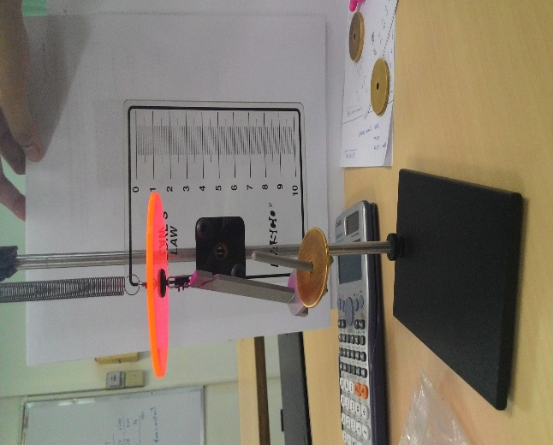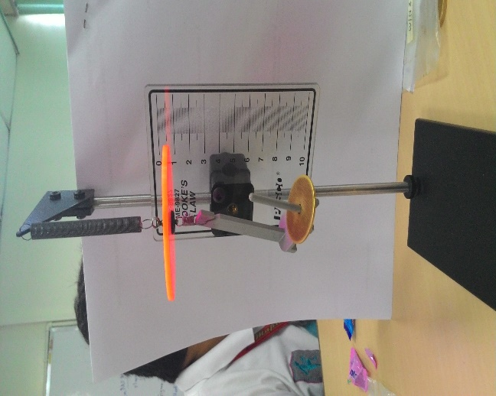
Figure 4: For trial 1, using a 4N/m spring, a 10-gram mass was added to the mass hanger. The displacement of the spring is 0.018 m
Figure 5: An 8N/m spring was used for the next trial. A 10-gram was placed on the mass hanger and its displacement is 0.009 m
Third section is determining the work done when the spring is loaded. By interpratig the data gathered in the second part, the total work done in stretching the spring was computed using Equation (2).
(2)
$$W=\frac{1}{2}k(x_{f}^{2}-x_{0}^{2})$$

Where: x_{f} = displacement in fourth trial of section two of the experiment
x_{o}= 0

The area under the graph of force vs. displacement was determined and compare the total work done and area under the graph of force vs. displacement.

- RESULTS AND DISCUSSION

In determining the force constant of the spring, data gathered are shown in Table 1A using 4N/m spring and Table 1B using 8N/m spring and the sample computations are presented below.

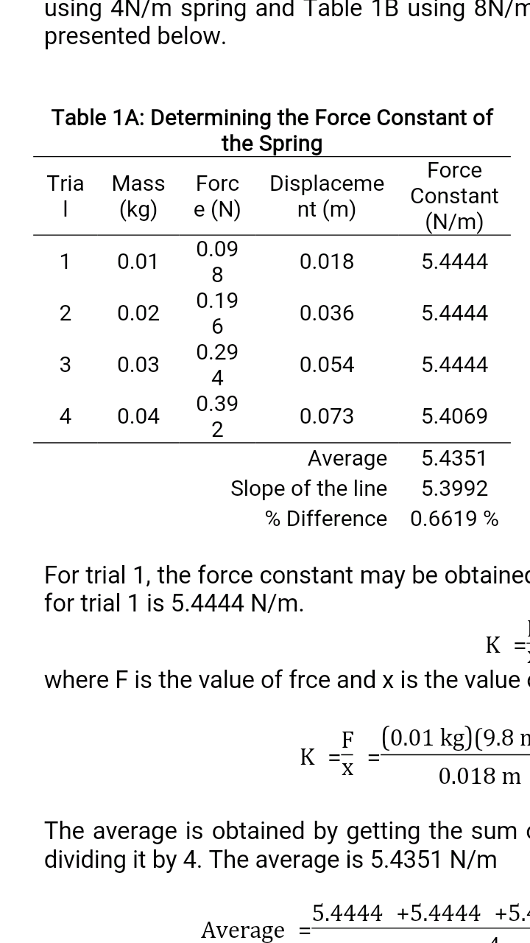
Table 1B

For trial 1, the force constant may be obtained by using Equation (3). The force constant for trial 1 is 5.4444 N/m.
(3)
$$K=\frac{F}{x}$$
Where F is the value of force and x is the value of the displacement.

$$K=\frac{F}{x}=\frac{\left(0.01 kg\right)(9.8 m/s^{2})}{0.018 m}=5.4444 N/m$$

The average is obtained by getting the sum of all the values of the force constant and dividing it by 4. The average is 5.4351 N/m

$$Average=\frac{5.4444+5.4444+5.4444+5.4069}{4}=5.4351 N/m$$

The average slope of the line can be obtained by using Equation 4. The slope of the line is 5.39 N/m. The percent difference is 0.6619%.

$Slope=\frac{F_{2}-F_{1}}{x_{2}-x_{1}}=\frac{0.392-0.098}{0.073-0.018}=5.39 N/m$ $AverageSlope=5.3992 N/m$

$$\% Difference=\frac{|5.4351-5.3992|}{(\frac{5.4351+5.3992}{2})}×100\%=0.6619\%$$
- DATA ANALYSIS
By analysing the graph, it shows that as the force increases, the distance or displacement also increases. It means that force is directly proportional to its displacement. Same with the results in Table 1B, the graph represents that the force is directly proportional to the displacement. Thus forming a straight line.

Sources of error for this part is that the alignment of the stretch indicator was not properly placed at zero. And the measurement of the displacement was not accurate.

Sample Computations:
For trial 1:

In determining the work done on the spring, the data gathered are shown in Table 2 and the sample computations are presented below.

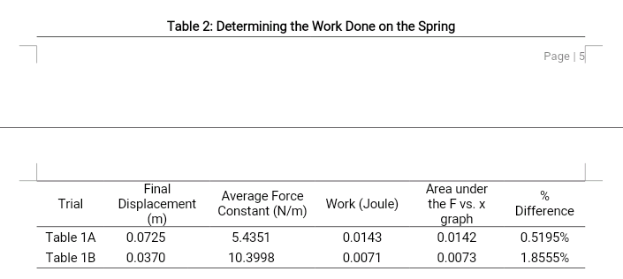
The work done can be obtained by using Equation (4). The work done in Table 1A and Table 1B is 0.0143 J and 0.0071 J respectively.

For table 1A: For table 1B
$Work=\frac{1}{2}\left(5.4351\right)\left({0.0725}^{2}-0\right)$ $Work=\frac{1}{2}\left(10.3998\right)\left({0.0370}^{2}-0\right)$

$=0.0143 J$ $=0.0071 J$
The area under the F vs. x graph, the equation $A=\frac{1}{2}bh$ is used. The area for Table 1A and Table 1B is 0.0142 m² and 0.0073 m² respectively.

For table 1A: For table 1B:
$Area=\frac{1}{2}\left(0.392\right)\left(0.0725\right)=0.0142 m^{2}$ $Area=\frac{1}{2}\left(0.392\right)\left(0.0370\right)=0.0073 m^{2}$
For the second part of the experiment, it shows if great the force applied on the spring due to adding weight, the greater the work done by the spring.
- ERROR ANALYSIS
Errors arose from;
- Misinterpretation of data i.e. inaccurate reading
It was observe that data obtained from the experiment had an error of 0.02
- Use of defective springs
Some of the spring s used did not stretchedas expected. It therefore means they did not have 100% accuracy, hence caused the error.

- CONCLUSIONS
In the first part of the experiment, it shows that the force is directly proportional to the displacement where if the force increases, the displacement also increases and vice versa. By looking at the graph, the plotted points are connected with a straight line and the slope is towards the positive direction. In the second part, it shows that the area under the F vs. x graph is proportional to the total work done. Error might occur while performing the experiment, one is that the stretch indicator was not properly aligned at point zero. Another is the measurement of the displacement because of the spring that is why we removed the mass after we measured for its displacement so that the spring won’t get loose.
At the end of the experiment, the objectives was attained. We were able to find the spring constant and work done on the spring when it is being stretched. From this experiment, we therefore concluded that force is directly to displacement.

REFERENCES
Hooke’sLaw.(n.d.). Retrieved from http://www.britannica.com/EBchecked/topic/271336/Hookes-law
Stress & Strain. (n.d.). Retrieved from http://physicsnet.co.uk/a-level-physics-as-a2/materials/stress-strain/
Elasticity and Hooke’s Law. (n.d). Retrieved from http://hyperphysics.phy-astr.gsu.edu/hbase/permot2.html

Appendices
